CloudFront is a content delivery network, or CDN.

It improves the read performance by caching the content of your website at the different edge locations. And because your content is cached all around the world, then your users all around the world will have a lower latency.  
CloudFront is made of 310+ Points of Presence globally, which correspond to the AWS edge locations around the world.  
You also get increased reliability and availability because copies of your files (also known as objects) are now held (or cached) in multiple edge locations around the world.

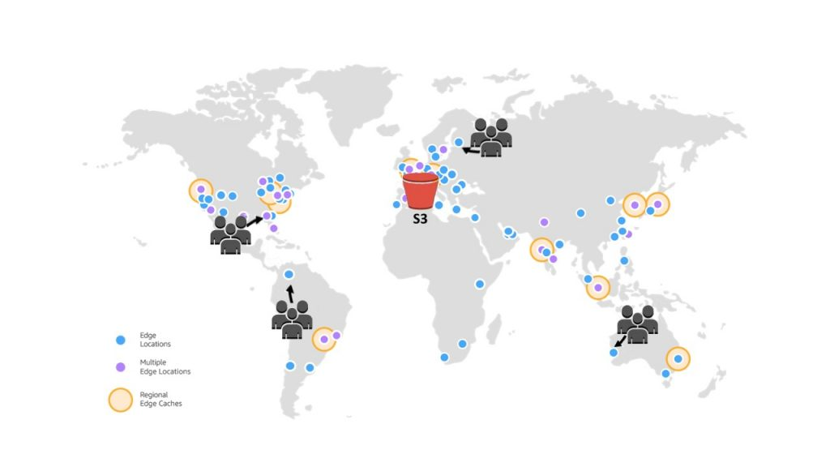

So, at a high level, how does CloudFront work?

We have the edge location all around the world. And then it will be connecting to the origin. So would it be an S3 bucket, or an HTTP server. And when the client connects and does an HTTP request into your edge location, then the edge location will see if it has it in the cache. If it doesn't have it in the cache, then it will go to the origin to get the request result. And then, once you retrieve the result, it will be caching it into your local cache, so that if another client requests the same content from the same edge location, then the edge location does not need to go to the origin.

So, this is amazing if you have static content that must be able to be available everywhere around the world.

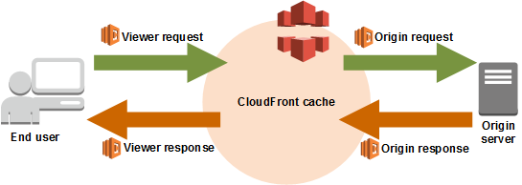

E.g. - The users accessing the edge location in across the globe will get their content directly served through the edge location, but first the edge location will get it from the origin S3 bucket through the private network. And the S3 bucket will be secured using CloudFront's OAI (Original Access Identity). So, this is the same when we have a user in Australia, for example Sydney. Again, this will be another edge location, which will be serving users close to Sydney. And then, it will be a private connection between your edge location and your S3 bucket, and so on. So, using CloudFront and the edge locations, we can see that the content of our S3 bucket in one region can be distributed all around the world through the edge locations or Points of Presence.

CloudFront use cases -

Accelerate static website content delivery - CloudFront can speed up the delivery of your static content (HTML, Style Sheet, JS, Images).

Serve video on demand or live streaming video - For video streaming, you can use CloudFront to stream in common formats such as MPEG DASH, Apple HLS, Microsoft Smooth Streaming and also for Broadcasting live stream

Encrypt specific fields throughout system processing.

Customize at the edge - Running serverless code at the edge opens up a number of possibilities for customizing the content and experience for viewers, at reduced latency